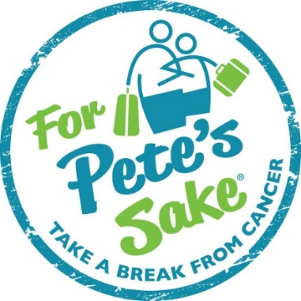
Your Generosity Has Changed Lives!
Dear Friend,

Each year countless adults are diagnosed with cancer and their lives, and the lives of their families,
are turned upside down. The future becomes uncertain and each moment becomes more precious than
the last. For Pete’s Sake Cancer Respite Foundation enables cancer patients and their loved ones to
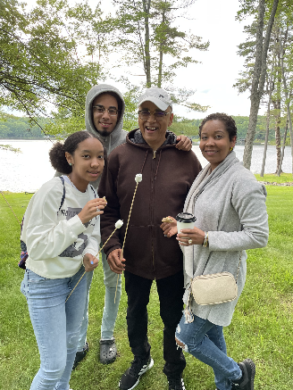
strengthen, deepen and unify their relationships by creating unforgettable respite vacations.
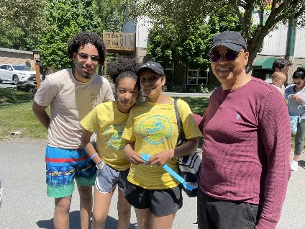
Alba was diagnosed with breast cancer in 2020. This diagnosis weighed heavily on her, her caregiver and her children. Adding to the fear of being diagnosed with cancer, Alba’s diagnosis and treatment started during the pandemic. Alba and her family felt very isolated and alone in her battle.
“After my respite I feel more energetic and enthusiasm to keep moving and to do what I love. Enjoying time with my family every single day, no matter what. Cancer will not stop me. My family and I just forgot about cancer and enjoyed the respite. We had an excellent time, it was priceless. This respite changed my life during this difficult time. I’ve learned that as a family we can have fun and that we need to enjoy every little moment. Life is too short to be sad.” – Alba, age 40
Thank you for your past sponsorship commitment to For Pete’s Sake, RUN! We invite you to help our patients “take a break from cancer” by supporting the For Pete’s Sake, RUN! Sea Isle City Beach Patrol’s - 50th Annual Captain Bill Gallagher 10 Mile Island Run on Saturday, August 14, 2021. *We recognize that each person reading this letter is experiencing personal challenges right now. If your own financial or health challenges are weighing heavily on you at this time, kindly disregard or defer this plea to better days. And please let us know if we can be of any help to you during this period of uncertainty. Please call FPS Founder & CEO, Marci Schankweiler at 267-708-0510 if we can help. We are all in this together!

The community of For Pete’s Sake Cancer Respite Foundation thanks you for your support as we celebrate life and the lives of all who have faced a cancer diagnosis and the unyielding physical and emotional demands of treatment.
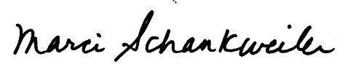
Warm Regards,
Marci B. Schankweiler, Esq.
Founder & CEO

For Pete’s Sake, RUN!
Sea Isle City Beach Patrol’s
Annual Captain Bill Gallagher 10 Mile Island Run

On August 14, 2014, the Annual Captain Bill Gallagher 10 Mile Island Run will take place in Sea Isle City, NJ. For Pete’s Sake Cancer Respite Foundation will once again be partnering with the Sea Isle City Beach Patrol to raise funds to send adult cancer patients and their loved ones on respite vacations.
This year, we are encouraging both new and previous runners to not only run 10 miles, but to also raise funds for our mission. Since 2010, FPS has raised over $100,000 through 10 Mile Island Run fundraising, truly making every stride count. We are asking you to sponsor Team FPS and help us reach this year’s fundraising goal of $20,000!
For $500 you will receive: For $300 you will receive:
- Logo on FPS’s event webpage - Listing on FPS’s event webpage
- One Color Logo on FPS T-shirt worn by runners during race - Listing on FPS T-shirt worn by runners during race
- Event signage recognition as a supporter of Team FPS - Event signage recognition as a supporter of Team FPS
at both the registration table and the finish line at both the registration table and the finish line
(over 1,000 runners are expected to participate this year) (over 1,000 runners are expected to participate this year)
- Recognition in FPS’s E-Newsletter - Recognition in FPS’s E-Newsletter
- One (1) mention on FPS Facebook/Twitter accounts status - One (1) mention on FPS Facebook/Twitter accounts status
The community at For Pete’s Sake Cancer Respite Foundation thanks you for your assistance. Together we can continue to bring joy into the lives of young adult cancer patients and their families.
Company Name as you would like it to appear on the shirt
Company Address
Company Phone
Contact Person Name
Contact Person Email
Estimated Value | $
Enclosed is my contribution for $________ payable to For Pete’s Sake: Cash Check Credit
Please charge my contribution to my credit card: Master Card Visa AmEx Discover
Name as it appears on card: ___________________________________________________________
Card Number: ______________________________________________________________________
Expiration Date: ______________________ CVV Number: __________________________________
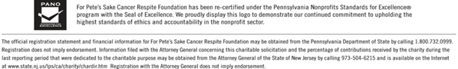
Signature: ______________________________________________________

